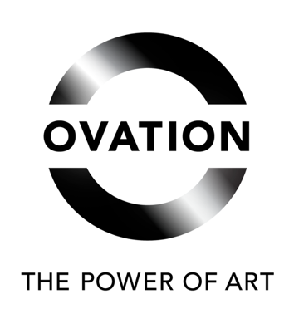

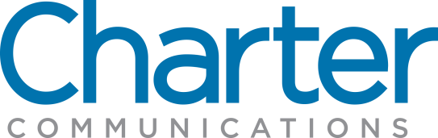

OVATION TV PARTNERS WITH CHARTER COMMUNICATIONS FOR SEVENTH CONSECUTIVE YEAR OF STAND FOR THE ARTS AWARDS

Ovation to Award $100,000 to 10 Arts and Cultural Organizations
in Charter Markets Across the Country

Los Angeles, CA – October 25, 2023 – Ovation TV, America’s premier arts network, and partner Charter Communications, Inc., today announced the recipients of the 2023-2024 Stand For The Arts Awards, which recognizes local arts, cultural and educational organizations and programs. Since the initiative started in 2017, Ovation TV and Charter have given out 70 awards totaling $700,000 towards arts education. This year, 10 organizations will receive support in Charter markets across the country.

Select arts organizations are awarded $10,000 Stand For The Arts contributions based on the following criteria: their support of creatives and artists via community-driven programming; as advocates for equity and access to the arts; and for providing accessible community spaces for creative expression.

“From Maine to Maui, Ovation TV and Charter continue to support and champion community-driven arts organizations across the country,” stated Sol Doten, Senior Vice President, Head of Marketing and Communications for Ovation TV. “It remains the priority of our Stand For The Arts partnership – seven years strong – to honor these arts organizations as they encourage and uplift artists on a local level.”

This year, recipients include Hui No‘eau Visual Arts Center in Maui, HI, which provides an array of programs that support lifelong learning in the arts including workshops and classes for all ages, lectures, exhibitions, art events, historical house tours, and educational outreach programs with both schools and community partner organizations. Hui No‘eau aims to ensure that access to the arts is a part of everyday life on Maui. Additional recipients include Columbus Children’s Theatre in Columbus, OH, which educates and involves young people of all backgrounds in the theatre arts through inclusive programs that foster self-esteem and self-discovery by emphasizing discipline, integrity, team-building, and communication skills in a positive and creative environment, and Bushwick Film Festival in Brooklyn, NY, a crucial platform for emerging filmmakers to showcase their work to a diverse and global audience, both in New York City and internationally. The festival, which belongs to the minority of only 12% of film festivals owned by women of color in the U.S., also develops filmmaking programs for underrepresented storytellers in Brooklyn and West Africa.

“We commend this year’s Stand For The Arts Award recipients for their support of local creatives and advocacy for accessibility to the arts through preservation, education and opportunity,” said Adam Falk, Senior Vice President, State Government Affairs for Charter. “Charter’s partnership with Ovation TV will help strengthen and uplift these vital arts and cultural organizations and continues our commitment to invest in and support the communities we serve.”

Along with a Stand For The Arts award, each organization will receive a $10,000 contribution to support their efforts. The Spectrum markets and the arts organizations being recognized are:

Columbiana, AL: Shelby County Arts Council
Maui, HI: Hui No'eau Visual Arts Center
Coeur d’Alene, ID: Coeur d’Alene Arts and Culture Alliance
Indianapolis, IN: Arts Council of Indianapolis
Rockland, ME: Center for Maine Contemporary Art
New York, NY: Bushwick Film Festival
Columbus, OH: Columbus Children's Theatre
Huntingdon, TN: The Dixie Carter Performing Arts & Enrichment Center
San Antonio, TX: Guadalupe Cultural Arts Center
Jackson, WY: Jackson Hole Public Art

More information about Stand For The Arts and the Stand For The Arts Awards is available at www.ovationtv.com/standforthearts.

About OVATION America’s Premier Arts Network
OVATION, majority owned by Hubbard Broadcasting Inc, is an independent television, production, and digital media company with unparalleled commitment to the arts, culture, and captivating entertainment. Showcasing a lineup of critically acclaimed premium dramas, specials, documentaries, and iconic films, OVATION salutes innovative storytelling with popular programming that includes Inside the Actors Studio, Murdoch Mysteries, Frankie Drake Mysteries, Arts Engines, The Fall, Midsomer Murders, The Art Of, Celebrity Conversations, and The Sound of New York. OVATION also powers JOURNY, the dedicated streaming service where art, culture, and travel intersect. The company has provided more than $15M in contributions and in-kind support to arts institutions and arts education. Its signature advocacy platform, STAND FOR THE ARTS, includes a coalition of over 150 arts organizations, cultural institutions, and arts leaders throughout the country raising awareness about art’s positive impact, protecting access for everyone, and encouraging action on behalf of the arts. OVATION is available on major providers via cable, satellite and telco systems including Comcast Cable/Xfinity, DIRECTV, Charter/Spectrum, Verizon FiOS, as well as on demand. You can follow OVATION on Facebook, Twitter, YouTube, Instagram, OvationTV.com, and through our App, OVATION NOW.

About Charter
Charter Communications, Inc. (NASDAQ:CHTR) is a leading broadband connectivity company and cable operator serving more than 32 million customers in 41 states through its Spectrum brand. Over an advanced communications network, the Company offers a full range of state-of-the-art residential and business services including Spectrum Internet®, TV, Mobile and Voice.

For small and medium-sized companies, Spectrum Business® delivers the same suite of broadband products and services coupled with special features and applications to enhance productivity, while for larger businesses and government entities, Spectrum Enterprise® provides highly customized, fiber-based solutions. Spectrum Reach® delivers tailored advertising and production for the modern media landscape. The Company also distributes award-winning news coverage and sports programming to its customers through Spectrum Networks. More information about Charter can be found at corporate.charter.com.

###

For more information, visit ovationtv.com or contact:

Roger Lawson
Senior Director of PR, Ovation TV
rlawson@ovationtv.com

Andrew Russell
Senior Director, Charter Communications, Inc.
andrew.russell@charter.com

